Multi-species coalescence and concatenation-based phylogeny of Avicennia species

Laleh Malekmohammadi¹, Masoud Sheidai^{1*}, Farrokh Ghahremaninejad², Afshin Danehkar³, Fahimeh Koohdar¹
¹Department of Plant Sciences and Biotechnology, Faculty of Life Sciences and Biotechnology, Corresponding author: Shahid Beheshti University, Tehran, Iran
²Department of Plant Sciences, Faculty of Biological Sciences, Kharazmi University, Tehran, Iran
³Department of Environmental Sciences, Faculty of Natural Resources, University of Tehran,
Karaj, Iran
* Corresponding author E-mail:msheidai@sbu.ac.ir

Abstract

Phylogenetic analyses of Avicennia species have been conducted using various molecular approaches, including sequencing of the chloroplast genome and multilocus analyses of nuclear genes. These studies have provided insights into the evolutionary relationships among Avicennia species and their placement within the Acanthaceae family. The concatenated sequences provide a more comprehensive dataset for phylogenetic analyses and can improve the accuracy of the resulting phylogenetic trees. The Multi-Species Coalescence (MSC) provides a powerful framework for several inference problems using genomic sequence data from multiple species, including the estimation of species divergence times and population sizes, the estimation of species trees that accommodate discordant gene trees, the inference of cross-species gene flow, and species delimitation. The genus Avicennia L., with about eight species, is among the important mangroves, some of which are growing in the southern parts of Iran. Controversy exists on the molecular phylogeny of Avicennia species; therefore, the present study was performed to use multispecies coalescent and concatenated-based phylogenetic analyses of molecular data (ITS and psbA sequences), to investigate the species relationships within the genus Avicennia. We used *BEAST (STARBEAST), and the contained gene analysis of Mesquite, as well as the Maximum likelihood phylogenetic tree construction based on the nuclear ITS and chloroplast psbA sequences. The results showed the presence of two major phylogenetically divergent clades within the studied species, with the occurrence of deep coalescence and interspecific introgression, along with DNA duplications and deletions.

Keywords: Avicennia, Multi-Species Coalescence, Molecular phylogeny, Incongruence, concatenated sequences, STAR BEAST.

1. Introduction

Mangroves are well adapted to harsh environments where other plant species are difficult to grow. Mangroves are highly adaptable and can withstand strong currents, high salinity, high temperatures, strong winds, and anaerobic conditions in their habitats (Naskar and Palit, 2015).Avicennia L. contains about eight species, namely, 1- A. germinans (L.) Stearn, 2- A. schaueriana Stapf & Leechm. exMoldenke, 3- A. bicolor Standley, 4- A. marina (Forssk.) Vierh, 5- A. alba Blume, 6- A. officinalis L., 7-A. integra N. C. Duke, and 8- A. rumphiana Hallier f (Li et al. 2016).
Despite their conservation importance, Avicennia species, there has been controversy over its classification and phylogenetic relationships (Li et al. 2016). Discrepancies between species trees and genes are a major problem in interpreting species phylogenies (James et al. 2009). New analytical approaches can help resolve the situation among which the concatenation and multispecies coalescence methods are very popular (Li et al. 2016; Degnan and Rosenberg 2009).

The analytical method in multispecies coalescence is the extended version of a single population coalescence, and is mainly based on the Wright–Fisher model which contains: Constant effective population sizes (Ne) within (but not necessarily across) populations; neutral evolution for the loci modeled; no structure within populations; and random joining of lineages backward in time (Degnan and Rosenberg 2009). In this sense, the gene lineages from different species trace backward through time, finding common ancestors at rates specified by the model. This coalescence of gene lineages occurs more anciently than the splitting times of the species to which they belong (Degnan and Rosenberg 2009).
Multi-Species Coalescence (MSC) combines the process of species’ divergence with the process of drift and mutation within populations.
Genome sequence data from multiple species are used to address some important biological questions, such as when species diverged, population sizes of extant species, and rates of gene flow between species. This method, by utilizing the heterogeneous gene genealogies across the genome, may be used to delineate the species boundaries (species delimitation). Moreover, MSC analysis of molecular phylogenetics tackles the so-called gene-tree–species-tree conflicts (Jiao et al. 2021).
We recently reported some of the genetic and phylogenetic aspects of these valuable species (Malekmohammadi et al. 2022, 2023). In these studies, we used different nuclear and chloroplast DNA markers to investigate the species’ barcoding and monophyly and produce some preliminary data on the Avicennia species’ phylogeny. The results revealed in some cases a significant monophyly of the studied species and some cases of admixture, which makes the phylogenetic and species delineation difficult. Therefore, we planned to perform a multispecies coalescence as well as concatenated phylogenetic analyses of molecular sequence data to improve and resolve the phylogenetic tree of the studied Avicennia species.

2. Materials and methods

2.1. Concatenation and multispecies coalescence analyses

For constructing a concatenation phylogenetic tree, we first downloaded the nuclear ITS and chloroplast psbA sequences of the six Avicennia species, as well as Sonneratia alba from the Lythraceae family and Bruguiera gymnorhiza from the Rhizophoraceae family. After downloading the sequences from NCBI (National Center for Biotechnology Information), they were then aligned and trimmed to be used in further analyses (Table1-6). We used a maximum likelihood phylogenetic method to study the concatenated data as performed in Mega 11 (Tamura et al.2021).

For multispecies coalescent analysis, we used two different approaches as performed in *BEAST (STARBEAST), and the Mesquite program Java ver. 20 (Maddison and Maddison, 2007). For *BEAST analyses, we first used BEAUti 2.7 to prepare the data format suitable for the analyses (Heled et al. 2010; Bouckaert et al. 2014). Both ITS and psbA sequences were used in this process.

The Hasegawa–Kishono–Yano (HKY) model of nucleotide substitution, along with the Gamma site model with category count = 4, was used in constructing phylogenetic trees. This model assumes that nucleotides occur at different frequencies and that transitions and transversions occur at different rates (Hasegawa et al. 1985).
We used the relaxed model of molecular evolution and the Youle model of speciation as priors, followed by 1000000000 times MCMC (Markov chain Monte Carlo) permutations.
In Species Tree Relaxed Clock, each species tree branch has an independent and identically distributed substitution rate with a LogNormal(mean = 1, logSD = Stddev) distribution, where Stddev is estimated (denoted by σ in the StarBeast3 manuscript). The substitution rates of each gene tree branch are from the species tree. The mean branch rate is fixed at 1 so that it does not interfere with tree height estimation. All gene clock rates were estimated and drawn from a Log-Normal prior. Due to the small number of loci, we left one of the gene trees fixed at 1.0. These gene clock rates are relative to the clock rate defined in the Species Clock Model tab, and thus were sampled from a prior with a mean of 1.
Additionally, the Clock rate (denoted by μ in the StarBeast3), we changed its default 1/X before in before the Log-Normal distribution centered around an informed estimate, and hence, the clock rate would be in units of substitutions per site per unit of time, so that the tree heights are in units of time (millions of years).
We also used the tracer program v1.6. to explore the output of BEAST. It summarizes graphically and quantitatively the distributions of continuous parameters and provides diagnostic information for the particular MCMC chain. The FigTree program V.1.4 was used for displaying and printing molecular phylogenies. Similarly, we uploaded the species and gene trees into the Ugly Trees (UT) program, which is a browser-based multispecies coalescent tree visualizer (Douglas, 2021; see https://uglytrees.nz/).

We used a tanglegram to explore the topological differences in the gene trees constructed by the ape package in R.4.2 (Paradis et al.2004). For coalescence analysis in the Mesquite program, we first constructed the ITS-based phylogenetic tree, followed by constructing a psbA-contained gene tree based on 10000 times coalescence. The number of gene duplications and extinctions as indicators of deep coalescence was obtained. The deep coalescence cost is equal to the number of gene losses minus two times the gene duplication cost in the reconciliation of a uniquely leaf-labeled gene tree and a species tree (Zhang, 2011).

We also used pcadapt R package 4.2 to identify biologically important outlier DNA SNPs (Luu et al.2017). Manhattan and Q-Q plots were generated,
and Bonferroni tests were applied to DNA SNPs.

2.2. DAPC (Discriminant Analysis of Principal Components) for inferring gene flow

We performed a discriminant analysis of principal components (DAPC) for genetic grouping and igraph-networking, as well as admixture analysis for gene flow determination between Avicennia species. These were performed in adegent (Jombart, 2008), LEA (Frichot and François, 2015), and the qgraph package in R. 4.2.

3. Results

3.1. Molecular phylogenies and sequence incongruence

Maximum Likelihood (ML) phylogenetic trees constructed based on the nuclear ITS sequences and chloroplast psbA nucleotides (Fig. 1) were incongruent to some degree, with the Robinson-Foulds = 0.20. To resolve this incongruence, we performed a phylogenetic analysis of the concatenated DNA sequences.

3.2. Concatenation analyses

A concatenated DNA sequence composed of the ITS and psbA sequences was constructed and used in further analyses. The Maximum Likelihood (ML) phylogenetic tree of this concatenated DNA sequence is presented in Fig. 2. It shows that two main clades are diverged from the outgroup taxa, one forming A. bicolor, A. germinans, and A. schaueriana, and the second grouping A. alba, A. officinalis, and A. marina. It also reveals some degree of admixture among the last three species.
Multivariate DAPC analyses of concatenated DNA sequences also produced almost 3 genetic groups, separating the outgroup taxa far from the other two groups of Avicennia studied (Fig. 3, A and B).

3.3. Genetic admixture and introgression

An admixture plot of Avicennia species based on concatenated DNA sequence is presented in Fig. 4, B. Some degree of introgression of sequence nucleotides is evident from this plot. Similarly, the igraph-network (Fig. 4., A), reveals the different magnitude of gene flow among the studied species. The thicker connecting lines indicate a higher magnitude of genetic similarity due to the common shared alleles.

Moreover, the result of the D-statistic test produced a significant result for ITS sequences when the four taxa used were Avicennia bicolor, A. germinans, and, A. schaueriana, along with the outgroup taxa (P-value = 2.432298e-07). This result indicates that ancient introgressions might have occurred within the clade comprising Avicennia bicolor, A. germinans, and, A. schaueriana, during species diversification.
A phylogenetic analysis of individual ITS nucleotides revealed that some of these nucleotides underwent introgression between Avicennia bicolor and, A. germinans, as these sequences produced paraphyly in the phylogenetic trees obtained (Fig. 5). Similarly, hybridization networks based on both ITS and psbA sequences revealed the occurrence of between species introgression (Fig. 6).
The contained gene tree obtained based on a 1000-time coalescence of the concatenated sequence data in the Mesquite program is provided in Fig. 7. It showed the deep coalescence value is 142, with 22 duplications and 186 extinctions. Therefore, these analyses indicate that deep coalescence and introgression have played a role in Avicennia species diversification.

3.4. STARBEAST analyses results

Bayesian phylogenetic analyses of *BEAST are provided in Fig. 8, A and, B. The Effective Sample Size (ESS) of the studied parameters sampled from MCMC in *BEAST was high enough as depicted in Tracer output (Fig. 8, A, and B). This is the number of effectively independent draws from the posterior distribution that the Markov chain is equivalent to.
Phylogenetic trees obtained for ITS and psbA sequences were uploaded to the Ugly Trees program to obtain the plot of species tree versus gene tree (Fig. 9). Two major clads are diverged from the outgroups, one forming A. bicolor, A. germinans, and A. schaueriana, and the second grouping A. alba, A. officinalis, and A. marina. The ugly tree of multispecies analysis also shows the occurrence of deep coalescence before speciation events. The Manhattan and Q-Q plots of the pcadap analyses identified four outlier SNP nucleotides, namely 17, 30, 35, and 42. Character history analysis of concatenated sequences by Mesquite also revealed that these sequences are the shared common SNPs of the two phylogenetic clades.

4. Discussion

The present study illustrates that phylogenetic relationships of Avicennia species based on the nuclear DNA ITS sequences differ from what can be obtained from chloroplast psbA sequences. Moreover, contained gene analysis revealed the occurrence of deep coalescence and ancient introgression in the studied taxa.
Therefore, we tackled the problem of phylogenetic trees’ incongruence with two approaches of constructing the phylogenetic tree based on the concatenated DNA sequences, and the multispecies coalescence method as implemented in *BEAST (STARBEAST), and the Mesquite programs. The results of this study identified two major phylogenetic clades diverged from outgroup taxa, one clade contains A. bicolor, A. schaueriana, and A. germinans, while the other three species, namely A. alba, A. marina, and A. officinalis, formed the second major clade.
Incongruence between the species and gene trees may occur because when we trace the history of the sampled species backward in time, sequences from different species may not coalesce as soon as they reach the most recent common ancestor on the species tree but instead coalesce in more ancient ancestors. This delayed coalescence or deep coalescence is also known as incomplete lineage sorting (Jiao et al. 2021). This phenomenon is more common when multiple species arise through a rapid succession of speciation events, which results in very short internal branches on the species tree relative to the coalescent waiting time.
We used both ML phylogenetic trees as well as the Bayesian MCMC-based coalescent method for our study. The ML method and Bayesian inference use the joint distribution of gene trees and coalescent times and operate on multilocus sequence data directly. It has been suggested that with more than three species, the Bayesian method has a computational advantage over ML, with the Markov chain Monte Carlo (MCMC) algorithm averaging over the gene trees and coalescent times (Jiao et al. 2021).
A recent study was performed on Avicennia species delineation (Malekmohammadi et al. 2022) by using trn L-F, trn-HG-psbA, and ITS sequences. These authors used ML phylogenetic analysis, which revealed that only the samples of A. alba can be differentiated from the other species, while the other species’ samples were somewhat scattered over the ML tree. Similarly, the analyses performed by the Bayesian method of species barcoding indicated that only 25% of the studied samples were successful in species identification, and the others may not be differentiated. From the present study, it seems that deep coalescence and ancient introgression are the possible reasons for improper species identification and delineation within the genus Avicennia.
Both D-statistics and admixture analyses revealed the occurrence of inter-species genetic admixture and introgression, probably in the areas closer to each other, as also reported by Mantiquilla et al. (2021) and, Malekmohammadi et al. (2022). We particularly reported inter-species introgression between A. germinans, and A. bicolor. A similar phenomenon has been reported to occur between A. germinans and, A. schaueriana by the other workers (Nettel et al. 2008, Mori et al. 2015).
Mantiquilla et al. (2021), reported a strong genetic structuring in Avicennia species resulting in divergence among mangrove populations of the Indian Ocean and South China Sea, as well as between South China Sea and Southwestern Pacific. Similarly, Malekmohammadi, et al. (2022), reported a distinct inter-specific genetic distance in Avicennia and a significant Fst value among different species both within those species distributed in the geographical regions of Australia, India, China, and those distributed in the regions of South America in general. Avicennia germinans, A. schaueriana, A. bicolor, occur in Atlantic-East Pacific (AEP) region, while A. alba, A. officinalis, and A. marina occur in the Indo-West Pacific region (IWP) (Duke, 1991).
The divergence time estimated for speciation within the genus Avicennia by Li et al. (2016) dates back to 1.8-6.0 MYA within the IWP clade. They also reported two divergence events within the A. marina complex (A. alba, A. officinalis, and A. marina), which were estimated to have occurred at 2.7 and 1.8 MYA, respectively. These results are in agreement with our own divergence date estimation of the genus Avicennia (Sheidai et al. 2024).

These molecular changes have been accompanied by deep coalescence, duplications, and deletions as well as inter-species introgression, mostly occurring within a specific geographical range as the geographical spread of Avicennia species is limited and mostly confined to the local area they grow (Mori et al. 2015).
However, as suggested by Mori et al. (2015), “the genetic structure of Avicennia species is influenced by intrinsic factors, such as mixed mating systems, biparental inbreeding, ongoing hybridization, and rate of gene flow through pollen and propagule dispersal, and also by extrinsic factors, such as marine currents and tidal patterns. The combination of this complex set of ecological features that shape the genetic diversity of A. germinans and A. schaueriana and historical processes, such as global climate changes after the last glacial maximum (LGM), may shed light on possible explanations for the current distribution of mangrove species in South America, and the Atlantic Caribbean East-Pacific Region (ACEP)”.
In conclusion, the present study produced insights into the Avicennia species’ divergence molecular mechanisms and provided evidence for the occurrence of deep coalescence, and inter-species introgression.

Declarations

Ethical Approval
not applicable

Competing interests
All authors have no conflict of interest

Authors' contributions

MS: Conceptualization of the project and designed the research ; LM: contributed to data collection and data analysis; FK and FG and AD: contributed to data analysis .

Funding
None

Availability of data and materials
The datasets analyzed during the current study are available from the corresponding author on reasonable request

References

Bouckaert RR, Heled J, Kühnert, D, Vaughan T, Wu CH, Xie D, Suchard, MA, Rambaut A, & Drummond, AJ (2014) BEAST 2: a software platform for Bayesian evolutionary analysis. PLoS Comput Biol 10(4), e1003537. https://doi.org/10.1371/journal.pcbi.1003537.

Degnan JH, Rosenberg, NA (2009) Gene tree discordance, phylogenetic inference and the multispecies coalescent. Trends Ecol Evol 24 (6): 332-340.https://doi.org/10.1016/j.tree.2009.01.009.

Douglas J (2021) UglyTrees: a browser-based multispecies coalescent tree visualiser. Bioinformatics. 37 (2): 268–269.https://doi.org/10.1093/bioinformatics/btaa679.

Duke NC (1991) A systematic revision of the mangrove genus Avicennia (Avicenniaceae) in Australasia. Aust Syst Bot.; 4(2):299±324.

Durand EY, Patterson N, Reich D et al (2011) Testing for ancient admixture between closely related populations. Mol Biol Evol 28: 2239–52.

Epskamp S, Costantini G, Haslbeck J, Cramer AO. (2017). RSVGTipsDevice S. Package ‘qgraph’.

Frichot E, François O.(2015). LEA: An R package for landscape and ecological association studies. Methods in Ecology and Evolution 6(8): 925-9.

Hasegawa M, Kishino H, Yano T (1985)"Dating of the human-ape splitting by a molecular clock of mitochondrial DNA". Journal of Molecular Evolution. 22 (2): 160–174. Bibcode:1985J MolE..22..160H. doi:10.1007/BF02101694. PMID 3934395. S2CID 25554168.

Heled J, Drummond AJ (2010) Bayesian inference of species trees from multilocus data. Mol Biol Evol 27(3), 570–580. https://doi.org/10.1093/molbev/msp274.

Jiao X, Flouri T, Yang Z (2021) Multispecies coalescent and its applications to inferspecies phylogenies and cross-species gene flow. Natl. Sci. Rev 8: nwab127.https://doi.org/10.1093/nsr/nwab127.

Jombart, T., 2008. adegenet: a R package for the multivariate analysis of genetic markers. Bioinformatics, 24(11), pp.1403-1405.

Li X, Duke NC, Yang Y, Huang L, Zhu Y, Zhang Z, Zhou R, Zhong C, Huang Y, Shi S (2016) Re-Evaluation of Phylogenetic Relationships among Species of the Mangrove Genus Avicennia from Indo-West Pacific Based on Multilocus Analyses. PLoS ONE.; 11(10): e0164453.

Luu K, Bazin E, Blum MG.(2017). pcadapt: an R package to perform genome scans for selection based on principal component analysis. Molecular ecology resources.17(1):67-77.

Maddison W, Maddison D.(2007). Mesquite 2. A Modular System for Evolutionary Analysis. Available online at: http://www. mesquiteproject. org..

Maguire TL, Saenger P, Baverstock P, Henry R (2000) Microsatellite analysis of genetic structure in the mangrove species Avicennia marina (Forsk.) Vierh. (Avicenniaceae). Mol Ecol. Nov;9(11):1853-62. doi: 10.1046/j.1365-294x.2000.01089.x. PMID: 11091321.

Malekmohammadi L, Sheidai M, Ghahremaninejad F, Danehkar A, Koohdar F (2023) Putative local adaptive SNPs in the genus Avicennia. Biochem. Genet, 1-16.https://doi.org/10.1007/s10528-023-10362-4

Malekmohammadi L, Sheidai M, Ghahremaninejad F, Danehkar A, Koohdar, F (2022) Avicennia genus molecular phylogeny and barcoding: A multiple approach. Caryologia 75(4): 3-13. doi: 10.36253/caryologia-1592.

Mantiquilla, JA, Shiao MS, Shih HWH, et al. (2021) A review on the genetic structure of ecologically and economically important mangrove species in the Indo-West Pacific, Ecol. Genet. Genom 18: 100078.https://doi.org/10.1016/j.egg.2020.100078.

Mori GM, Zucchi MI, Sampaio, I. et al. (2015) Species distribution and introgressive hybridization of two Avicennia species from the Western Hemisphere unveiled by phylogeographic patterns. BMC Evol Biol 15, 61. https://doi.org/10.1186/s12862-015-0343-z

Naskar S, Palit PK (2015) Anatomical and physiological adaptations of mangroves. Wetlands Ecol Manage 23, 357–370. https://doi.org/10.1007/s11273-014-9385-z.

Nettel A, Dodd RS, Afzal-Rafii Z, Tovilla-Hernández C (2008) Genetic diversity enhanced by ancient introgression and secondary contact in East Pacific black mangroves. Mol Ecol 17:2680–90.

Paradis E, Claude J, Strimmer K.(2004). APE: analyses of phylogenetics and evolution in R language. Bioinformatics. 22;20(2):289-90.

Sheidai, M., Malekmohammadi, L., Ghahremaninejad, F. et al. (2024). A new computational method to estimate adaptation time in Avicennia by using divergence time. Sci Rep 14, 24158 (2024). https://doi.org/10.1038/s41598-024-74064-6

Tamura, K., Stecher, G. and Kumar, S., (2021). MEGA11: molecular evolutionary genetics analysis version 11. Molecular biology and evolution, 38(7), pp.3022-3027.

Zhang L. (2011). From gene trees to species trees II: species tree inference by minimizing deep coalescence events. IEEE/ACM Trans Comput Biol Bioinform 8(6):1685-91. doi: 10.1109/TCBB.2011.83.

Table 1. Voucher information and GenBank accession numbers of taxa sampled for the genus Avicennia based on ITS data.
Taxa | Accession number ( ITS) | Country
Avicennia alba | AF365980.1 | Australia
Avicennia alba | MG880036.1 | Vietnam
Avicennia alba | MG880028.1 | Bangladesh
Avicennia alba | EU528876.1 | Singapore
Avicennia alba | KX641594.1 | Indo-West Pacific
Avicennia bicolor | EF540988.1 | Costa Rica
Avicennia bicolor | EF540987.1 | Costa Rica
Avicennia bicolor | EU352151.1 | Mexico
Avicennia bicolor | AF365977.1 | Australia
Avicennia bicolor | EU528877.1 | Costa Rica
Avicennia germinans | EU352147.1 | Mexico
Avicennia germinans | KX641596.1 | Indo-West Pacific
Avicennia germinans | MG880041.1 | Cuba
Avicennia germinans | MG880040.1 | Germany
Avicennia germinans | DQ469846.1 | Panama
Avicennia integra | KX641598.1 | Indo-West Pacific
Avicennia officinalis | MH243949.1 | India
Avicennia officinalis | MH243948.1 | India
Avicennia officinalis | MG880054.1 | Bangladesh
Avicennia officinalis | MG880053.1 | Bangladesh
Avicennia officinalis | KX641597.1 | Indo West Pacific
Avicennia rumphiana | KX641595.1 | Indo-West Pacific
Avicennia schaueriana | EF540986.1 | Guadeloupe
Avicennia schaueriana | DQ469862.1 | Brazil
Avicennia schaueriana | AB861412.1 | Brazil
Avicennia schaueriana | AB861385.1 | Brazil
Avicennia schaueriana | AB861382.1 | Brazil
Avicennia marina | MF063712.1 | China
Avicennia marina | EF540978.1 | Australia
Avicennia marina | MN883387.1 | Saudi Arabia
Avicennia marina | MN883384.1 | Egypt
Avicennia marina | MH243942.1 | India

Table2. Voucher information and GenBank accession numbers of taxa sampled for the genus Avicennia based on psbA data.
Taxa | Accession number | Country
Avicennia alba | KT453639 | Thailand
Avicennia alba | MZ405095.1 | Philippines
Avicennia alba | MN117549.1 | India
Avicennia alba | MN117551.1 | India
Avicennia alba | MN117553.1 | India
Avicennia bicolor | KC420633.1 | Africa
Avicennia germinans | KJ426610.1 | Puerto  Rico
Avicennia germinans | KT453640.1 | China
Avicennia germinans | KC420634.1 | Africa
Avicennia germinans | OL312420.1 | USA
Avicennia germinans | OK636541.1 | China
Avicennia officinalis | KT453644.1 | Thailand
Avicennia officinalis | KT161361.1 | Thailand
Avicennia officinalis | MZ405097.1 | Bangladesh
Avicennia officinalis | MN117563.1 | India
Avicennia officinalis | MN117559.1 | India
Avicennia marina | KT161360.1 | Thailand
Avicennia marina | MZ405092.1 | South Africa
Avicennia marina | MZ405090.1 | China
Avicennia marina | MZ405086.1 | Malasya
Avicennia marina | LC604869.1 | Japan

Table3. Voucher information and GenBank accession numbers of taxa sampled for Sonneratia alba based on psbA data.

Taxa | Accession number (psbA-trnH) | Country
sonneratia alba | MH583032.1 | China
Sonneratia alba  Sonneratia alba | LC604868.1  OK636997.1 | Japan  China

Table 4. Voucher information and GenBank accession numbers of taxa sampled for Sonneratia alba based on ITS data.

Taxa | Accession number (ITS) | Country
Sonneratia alba | KJ511914.1 | Australia
Sonneratia alba  Sonneratia alba  Sonneratia alba | KJ511906.1  KJ511903.1  AY674889.1 | China  Thailand  China

Table 5. Voucher information and GenBank accession numbers of taxa sampled for Bruguiera gymnorhiza based on ITS data.

Taxa | Accession number (ITS) | Country
Bruguiera gymnorhiza | KC460265.1 | China
Bruguiera gymnorhiza  Bruguiera gymnorhiza | HM366107.1  HM366104.1 | indo-west pacific  indo-west pacific

Bruguiera gymnorhiza HM366094.1 China

Table 6. Voucher information and GenBank accession numbers of taxa sampled for Bruguiera gymnorhiza based on psbA data.

Taxa | Accession number (psbA-trnH) | Country
Bruguiera gymnorhiza | KJ559424.1 | China
Bruguiera gymnorhiza  Bruguiera gymnorhiza | OK636591.1  OK636589.1 | China  China

Bruguiera gymnorhiza MN117584.1 India

Fig. 1. Tanglegram based on BEAST phylogenetic trees of ITS and psbA sequences in the studied Avicennia species show some degree of tree incongruence.

Fig. 2.

The ML phylogenetic tree of the concatenated DNA sequence shows that two main clades are diverged from the outgroup taxa, one forming A. bicolor, A. germinans, and A. schaueriana, and the second grouping A. alba, A. officinalis, and A. marina.

Fig. 3. A and B show DAPC genetic grouping and the assignment plot of concatenated DNA sequences in Avicennia studied.

Fig. 4. A-Igraph network ( Bc = Avicennia bicolor, gr = A. germinans, sc = A. schaueriana, al = A. alba, of = A. officinalis, and mr = A. marina).
B- Admixture plot of Avicennia species based on a concatenated sequence shows the magnitude of gene flow and admixture among the studied taxa (Individuals from left to right are the species in Table 1).

Fig. 5. Representative concatenate-DNA phylogenetic trees based on a single nucleotide, show that paraphyly occurs due to introgression between Avicennia bicolor, A. schaueriana and A. Germinans.

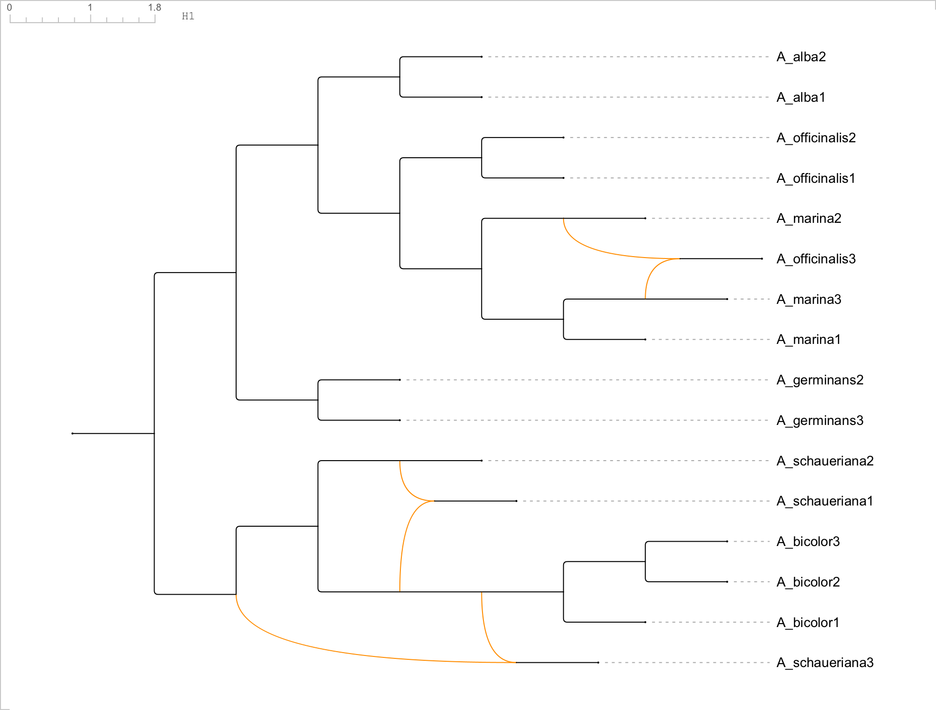

Fig. 6. A- Hybridization network of the ITS sequences across Avicennia species.

B- Hybridization network of the psbA sequences across Avicennia species.

Fig. 7. The contained gene tree was obtained based on a 1000-time coalescence of the concatenated sequence data, showing a deep coalescence value.
(Deep coalescence cost is equal to the number of gene losses minus two times the gene duplication cost in the reconciliation of a uniquely leaf-labeled gene tree and a species tree (Zhang, 2011).

Fig. 8, A and B, are *BEAST tracer outputs that show the adequate number of effective sample sizes (ESS = 1865) of the studied parameters.

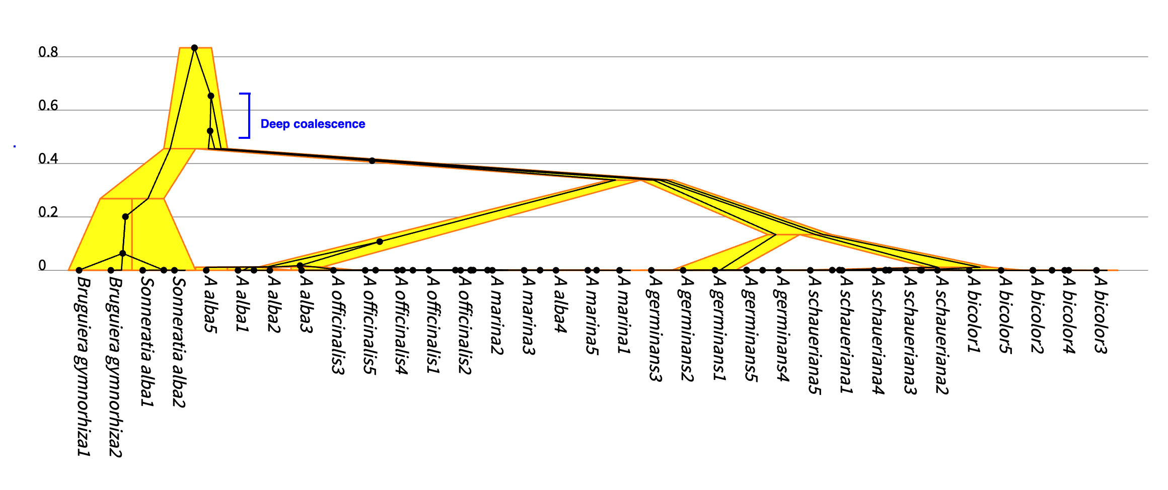

Fig. 9. Ugly tree output shows the gene tree (psbA sequences), within the species tree (ITS sequences), in the Avicennia species studied.

